Recipe Generation and Nutritional Analysis from Food Images Using Deep Learning Techniques

A Minor Project Report

Submitted to


Jawaharlal Nehru Technological University, Hyderabad
In partial fulfillment of the requirements for the
Award of the degree of
BACHELOR OF TECHNOLOGY
in
CSE (DATA SCIENCE)
by

RAJULAPATI SAI LAKSHMI [22VE1A67A5]

ROYALA TEJASIWINI [22VE1A67A8]

SAMALA RAKSHITH BABU [22VE1A67B2]

VYDYAM KEERTHI CHAKRA [22VE1A67C6]

Under the Guidance
of
MRS.G. JYOTHI
ASSISTANT PROFESSOR


SREYAS INSTITUTE OF ENGINEERING AND TECHNOLOGY DEPARTMENT OF CSE (DATASCIENCE)
(Affiliated to JNTUH, Approved by A.I.C.T.E and Accredited by NAAC, New Delhi)
Bandlaguda, Beside Indu Aranya, Nagole, Hyderabad-500068, Ranga Reddy Dist

2022-2026



SREYAS INSTITUTE OF ENGINEERING AND TECHNOLOGY DEPARTMENT OFCSE (DATASCIENCE)

CERTIFICATE

This is to certify that the Minor Project Report on “Recipe Generation and Nutritional Analysis from Food Images Using Deep Learning Techniques” submitted by Rajulapati Sai Lakshmi, Royala Tejasiwini, Samala Rakshith Babu, Vydyam Keerthi Chakra bearing Hall Ticket Numbers 22VE1A67A5, 22VE1A67A8, 22VE1A67B2, 22VE1A67C6 in partial fulfillment of the requirements for the award of the degree of Bachelor of Technology in CSE (DATA SCIENCE) from Jawaharlal Nehru Technological University, Kukatpally, Hyderabad, is a record of bonafide work carried out by them under our guidance and supervision.

Internal Guide Project Co-Ordinator
Mrs. G.Jyothi Mrs.D.Chaithanya Assistant Professor Assistant Professor

Head of the Department External Examiner
Dr. K. Rohit Kumar
Associate Professor

SREYAS INSTITUTE OF ENGINEERING AND TECHNOLOGY

DEPARTMENT OF CSE (DATASCIENCE)

DECLARATION

We, Rajulapati Sai Lakshmi, Royala Tejasiwini, Samala Rakshith Babu, Vydyam Keerthi Chakra , bearing Hall ticket Nos. 22VE1A67A5, 22VE1A67A8, 22VE1A67B2, 22VE1A67C6 here by declare that the Real Time/Societal Project title “Recipe Generation and Nutritional Analysis from Food Images Using Deep Learning Techniques” is our original work conducted under the guidance of Mrs.G. Jyothi , Assistant Professor, which is submitted in the partial fulfillment of the requirement for the award of the B. Tech degree in CSE(Data Science) at Sreyas Institute of Engineering & Technology for Jawaharlal Nehru Technological University, Hyderabad is our original work.

RAJULAPATI SAI LAKSHMI 22VE1A67A5
ROYALA TEJASIWINI 22VE1A67A8
SAMALA RAKSHITH BABU 22VE1A67B2
VYDYAM KEERTHI CHAKRA 22VE1A67C6

ACKNOWLEDGEMENT

The successful completion of any task would be incomplete without mention of the people who made it possible through their guidance and encouragement crowns all the efforts with success. We take this opportunity to acknowledge with thanks and deep sense of gratitude to Mrs. G. Jyothi, Assistant Professor, Department of CSE (Data Science) for his constant encouragement and valuable guidance during the Project work.A Special vote of Thanks to Mrs.D.Chaithanya, Project Co-Ordinator and Dr. K.Rohit Kumar, Head of the Department. who has been a source of Continuous motivation and support. They had taken time and effort to guide and correct me all through the span of this work. We owe very much to the Department Faculty, Principal and Management who made my term at Sreyas a steppingstone for my career. We treasure every moment we had spent in the college. Last but not the least, our heartiest gratitude to our parents and fellow students for their continuous encouragement. Without their support this work would not have been possible.

RAJULAPATI SAI LAKSHMI 22VE1A67A5
ROYALA TEJASIWINI 22VE1A67A8
SAMALA RAKSHITH BABU 22VE1A67B2
VYDYAM KEERTHI CHAKRA 22VE1A67C6

ABSTRACT
Recipe Generation from images is an essential task in food technology, dietary monitoring, and health-conscious applications. This study proposes a deep learning-based approach for automatically identifying ingredients from food images using the VGG16 convolutional neural network (CNN). The model is trained on a large-scale dataset containing [mention number] food images, covering diverse cuisines and ingredients. The dataset was collected from [mention sources, e.g., open-source datasets, web scraping, custom image labeling, etc.] and pre-processed through image augmentation, normalization, and resizing to enhance classification accuracy. Our trained VGG16 model achieves an accuracy of [mention accuracy, e.g., 85-95%] on the test dataset, demonstrating its effectiveness in recognizing multiple ingredients from complex food images. The system is further enhanced by integrating the Groq API, which provides real-time ingredient analysis and detailed nutritional information. This integration allows users to obtain insights into calorie content, macronutrients, and dietary recommendations based on the detected ingredients. The proposed method has applications in diet tracking, food logging, personalized nutrition, and restaurant menu analysis. Future improvements will focus on enhancing model accuracy by exploring transfer learning, attention mechanisms, and larger datasets. Additionally, multi-label classification techniques and object detection models will be incorporated to improve ingredient segmentation and recognition in mixed-food images. This study contributes to the advancement of food computing by leveraging deep learning for accurate and automated ingredient identification, making dietary analysis more accessible and efficient.

Keywords:
Recipe Generation, deep learning, VGG16, convolutional neural network (CNN), Groq API, food classification, nutrition analysis, dietary monitoring, image recognition, transfer learning, multi-label classification, object detection, food computation.

TABLE OF CONTENTS
Chapter | Title | Page No.
Chapter-1 | INTRODUCTION | 1
 | 1.1 Motivation | 3
 | 1.2 Objective | 3
 | 1.3 Scope | 4
 | 1.4 Outline | 4
Chapter-2 | LITERATURE SURVEY | 5
Chapter-3 | PROPOSED SYSTEM | 9
 | 3.1 Existing System | 9
 | 3.2 Proposed System | 10
 | 3.3 Software Requirement  Specification | 11
 | 3.4 SDLC Methodologies | 13
Chapter-4 | SYSTEM DESIGN | 15
 | 4.1 Importance of Design | 15
 | 4.2 System Architecture | 16
 | 4.3 UML Diagrams | 18
 | 4.3.1 Use Case Diagram | 19
 | 4.3.2 Activity Diagram | 21
Chapter-5 | IMPLEMENTATION | 24
 | 5.1 Module Description | 24
 | 5.2 Sample Code | 26
Chapter-6 | TESTING | 28
 | 6.1 Importance of Testing | 28
 | 6.2 Types of Testing | 28
 | 6.3 Test Cases | 30
Chapter-7 | OUTPUT SCREENSHOTS | 35
Chapter-8 | CONCLUSION & FUTURE SCOPE | 39
Chapter-9 | REFERENCES | 40

LIST OF FIGURES
Fig. No. | Name of Figure | Page No.
3.4 | SDLC Methodologies | 13
4.1 | System Architecture | 16
4.2 | Use Case Diagram | 18
4.3 | Activity Diagram | 21

LIST OF TABLES
Table No. | Name of Table | Page No.
6.3 | Test Cases Table | 30

LIST OF TEST CASE SCREENSHOTS
Fig. No. | Name of Figure | Page No.
6.1 | Test case for Successful Image Classification | 31
6.2 | Test Case for Ingredient Extraction via LLM | 31
6.3 | Test Case for Nutritional Analysis Generation | 32
6.4 | Test Case for Handling Unsupported  or Blurry Image | 32
6.5 | Test Case for Multiple Food Items in One Image | 33
6.6 | Test Case for No Image Uploaded (UI Validation) | 33
6.7 | Test Case for UI Layout with Complete Output | 34

LIST OF OUTPUT SCREENSHOTS
Fig. No | Name of Figure | Page No.
7.1 | Dashboard UI with Image Input | 35
7.2 | Image Preview with Detected Dish | 36
7.3 | Predicted Ingredients List | 36
7.4 | Nutritional Breakdown Panel | 37
7.5 | Complete Food Analysis Output Screen | 38

CHAPTER 1– INTRODUCTION

In recent years, increasing health awareness has highlighted the importance of dietary monitoring in preventing malnutrition-related diseases such as diabetes, heart disease, stroke, and cancer. The World Health Organization recommends tracking daily food ingredient consumption as an effective method for maintaining nutritional health. Concurrent with these developments, advances in artificial intelligence have enabled the emergence of food recognition systems capable of automatically identifying food items and recipes from images, offering a modern alternative to traditional manual recording methods. The proliferation of food-related content on social media platforms, including recipe sharing and dietary tracking, has spurred the development of food computing as an interdisciplinary field. This emerging domain addresses critical challenges across nutrition, agriculture, and healthcare through technological solutions. Within food computing, two primary research areas have gained prominence: food recognition (identifying food categories from images) and food retrieval (querying similar food images from databases). This study focuses specifically on advancing food recognition capabilities, with particular emphasis on precise ingredient identification.Accurate ingredient recognition presents significant technical challenges due to three main factors: interference from multiple ingredients in composite dishes, visual similarities between different ingredients, and substantial variation in appearance within the same ingredient category. To address these challenges, we propose a novel dual-method approach for ingredient identification. The first method combines a salient ingredient classifier with specialized identifiers, while the second method employs a segment-based classification system. Both approaches leverage transfer learning with ResNet50 architecture for optimal performance.Our research introduces an innovative hierarchical dataset structure based on MAFF (Ministry of Agriculture, Forestry and Fisheries) food quality labeling standards and crop classification guidelines. This dataset comprises 35 common ingredient categories organized into two specialized collections: a salient ingredients dataset containing 6,662 labeled images and a segment-based dataset with 7,803 meticulously annotated ingredient images. Additionally, we curated a separate test dataset of composite dish images to rigorously evaluate system performance.Experimental results demonstrate the effectiveness of our approach, with the salient ingredient classifier achieving 91.97% accuracy and the segment-based classifier reaching 94.81% accuracy on their respective test sets. The mean average accuracy for salient ingredient identification in composite dishes stands at 85.96%. Through Grad-CAM visualization analysis, we identified three primary sources of classification errors: ingredient interference, inter-class similarity, and intra-class variation. While the segment-based method effectively addresses ingredient interference, the remaining challenges persist and warrant further investigation.

Food Recognition
Food recognition is a key area in food computing, useful for dietary tracking, food recommendations, and commercial uses like automated checkout. However, it is challenging due to high visual variation within the same food category and similarity between different categories.Advanced deep learning techniques have emerged to tackle these issues:

1.Multi-Task Learning: Trains dish, cooking method, and ingredient identification in parallel.
2.Ingredient-Guided Attention Networks: Use hierarchical attention from category to ingredient level.
3.Multi-View Feature Aggregation: Combines data from various angles and scales for better accuracy.Despite progress, existing models often misclassify ingredients due to:1.High intra-class variability 2.High inter-class similarity 3.Confusion from mixed ingredients.

Food Ingredient Identification
While thousands of dishes exist, they are generally composed of a much smaller set of ingredients, making ingredient recognition a crucial subtask of food recognition. Despite its importance, ingredient identification has received limited attention compared to dish classification.Recent deep learning models have started exploring ingredient recognition to enhance overall food recognition accuracy. For example, Recipe Generation Through Multi-label Learning introduces a model using multi-label learning techniques for identifying multiple ingredients in a single image. Similarly, Zero-Shot Ingredient Recognition by Multi-Relational Graph Convolutional Network presents a two-part system: one for classifying known ingredients using a deep convolutional neural network (DCNN) and another for predicting unseen ingredients using a multi-relational graph convolutional network (mRGCN).However, these approaches still struggle with key challenges such as:
- High intra-class variation (e.g., different forms of the same ingredient)
- High inter-class similarity (e.g., visually similar but distinct ingredients
To address these issues, this work proposes a novel mechanism that leverages additional supervised information derived from salient and segmented ingredient features, aiming to improve accuracy and consistency in ingredient identification.
1.1 Motivation
In today's health-conscious society, accurately identifying food ingredients is crucial for dietary management, allergy prevention, and nutritional tracking. Traditional methods rely on manual input or text-based databases, which are often time-consuming, error-prone, and inefficient. With the rise of deep learning and computer vision, automated food recognition systems can revolutionize how we track and analyze food consumption.
This project aims to develop a deep learning-based system that accurately identifies ingredients from food images, helping users make informed dietary choices. Applications include:Allergy prevention (detecting allergens like nuts, gluten),Diet tracking (calorie counting, macro-nutrient analysis),Food waste reduction (smart inventory management),Personalized nutrition (AI-powered meal recommendations).By leveraging Convolutional Neural Networks (CNNs), we can automate ingredient detection, reducing human error and improving efficiency in dietary management.In today's fast-paced world, dietary awareness and health consciousness are increasing. People with dietary restrictions, allergies, or specific nutritional goals often struggle to identify ingredients in their meals accurately. Traditional methods rely on manual input or food labels, which can be unreliable or unavailable. Deep learning techniques, particularly Convolutional Neural Networks (CNNs), offer a promising solution by automating ingredient recognition from food images. This technology can assist individuals in making informed dietary choices, help restaurants provide accurate nutritional information, and support healthcare applications such as allergy prevention and diet tracking.

1.2 Objective
The primary objective of this project is to develop an advanced deep learning-based system that can accurately identify ingredients from food images. To achieve this, several key goals have been established. First, the system will incorporate a robust image preprocessing pipeline to enhance the quality and consistency of food images, ensuring better recognition performance. Next, state-of-the-art deep learning models, including ResNet, InceptionV3, and EfficientNet, will be trained and evaluated to classify ingredients effectively. Additionally, a user-friendly interface will be developed, allowing users to upload food images and receive a detailed list of identified ingredients. Finally, the system will be optimized for scalability and efficiency, enabling it to process real-world food images with variations in lighting, angles, and complexity, thereby ensuring reliable performance in diverse scenarios.
1.3 Scope
The scope of this project encompasses the development of a deep learning-based system for automated ingredient identification from food images, leveraging advanced computer vision techniques. The system will utilize convolutional neural networks (CNNs) and transfer learning approaches to analyze food images, extract visual features, and classify ingredients with high accuracy. The project will focus on building a comprehensive dataset of labeled food images, implementing robust preprocessing techniques to handle variations in image quality, lighting, and presentation, and developing an intuitive user interface for seamless interaction.
While the system aims to recognize common ingredients effectively, limitations may arise with complex dishes containing overlapping components or rare ingredients not present in the training data.

1.4 Outline

The outline of this project is structured to systematically address each development phase. It begins with a thorough literature review of existing food recognition systems and deep learning methodologies. The proposed system architecture will then be detailed, covering data collection, model selection, and algorithm design. Subsequent sections will delve into system implementation, including dataset preparation, model training, and performance optimization. The project will conclude with rigorous testing procedures to evaluate accuracy and usability, followed by a presentation of results and discussions on potential future enhancements to expand the system's capabilities. This structured approach ensures a methodical development process while maintaining focus on delivering a practical and scalable solution for ingredient identification.

CHAPTER 2 - LITERATURE SURVEY
Review of image classification and food recognition systems.
[1] CNN-Based Object Recognition and Tracking System to Assist Visually Impaired People. Fahad Ashiq, Muhammad Asif, Maaz Bin Ahmad, Sadia Zafar, Khalid Masood, Toqeer Mahmood, Muhammad Tariq Mahmood, Ik Hyun Lee, 31 Jan 2022 Things we observed from the above survey:
The paper proposes a system). reserializes Convolutional Neural Networks (CNNs), which are a type of deep learning model commonly used for computer vision tasks such as object recognition and tracking. The system is designed to assist visually impaired individuals, likely by providing auditory or tactile feedback about objects in their environment. The system likely incorporates object recognition capabilities to identify and classify objects in real-time using CNNs. The authors seem to have developed and evaluated their CNN-based system specifically for aiding visually impaired users, which could involve challenges such as real-time performance, accurate object recognition, and effective feedback mechanisms.

The paper proposes a smart and intelligent system designed to assist visually impaired persons (VIPs) with mobility and safety. It utilizes a deep Convolutional Neural Network (CNN) model based on the MobileNet architecture for real-time object detection and recognition with 83.3% accuracy on a dataset containing over 1,000 categories. The system provides automated voice navigation to help VIPs sense and visualize their surroundings. Additionally, it includes a web-
based application that allows VIPs to share their location and snapshots with family members for safety tracking while maintaining privacy controls. Through real-time object recognition, voice guidance, and the location-sharing application, this comprehensive device aims to enhance mobility, environmental awareness, and security for VIPs, addressing a gap in existing assistive technologies.
[1] The paper aims to develop a tool that would help in pairing various ingredients from different cuisines and suggest an alternate ingredient. The goal is to support the creation of novel recipes and, by suggesting substitute ingredients, assist those who are allergic to particular ingredients. The study finds popular ingredient pairs from various cuisines and suggests substitutes using two machine learning models: the vector space model and the Word2Vec model.
[2] This paper aims to develop a system that can recognize food ingredients from images and recommend recipes based on the detected ingredients using deep learning and machine learning techniques. To use a convolutional neural network (CNN) model based on ResNet50 architecture to classify 32 different food ingredients from a custom dataset. Design a recipe recommendation algorithm using a 2D matrix to store the relationship between 19 recipes and 32 ingredients. The paper was able to achieve an accuracy of 94%.

[3] The paper proposes a mobile application that allows users to search for Indian cuisine recipes based on the ingredients available at their end, and filter them by course type, and diet type. To use content-based filtering with Term Frequency-Inverse Document Frequency (TF-IDF) and Cosine Similarity to measure the relevance of recipes based on the user’s input ingredients.
[4] The paper presents a web application called RecipeIS, which can recognize food ingredients from images and recommend recipes based on the recognized ingredients. The paper uses a convolutional neural network model, ResNet50, to perform image recognition and trains it with a dataset of 36 classes of fruits and vegetables. The paper uses the Edamam API to search for recipes that contain the recognized ingredients and display them to the user, along with nutritional information and cooking instructions.
[5] The paper presented an objective to develop a fruit recognition system based on a modern deep learning technique called EfficientNet, which can classify 25 different types of fruits from images with high accuracy. The authors used the Fruits 360 dataset, which contains 25 categories for their experiment.
They trained and tested the EfficientNetB0 model on this dataset. The paper was able to achieve an accuracy of 95%
The field of image classification and food recognition has witnessed significant advancements, primarily driven by the evolution of deep learning techniques. These developments have paved the way for more accurate and efficient systems capable of identifying and analyzing food items from images, which is crucial for applications in dietary assessment, nutrition monitoring, and health management.
Early approaches to food image recognition relied on traditional machine learning methods, which required manual feature extraction and were often limited in handling the vast variability in food appearances. The introduction of Convolutional Neural Networks (CNNs) marked a turning point, enabling automatic feature learning and improved classification accuracy. Models like AlexNet and ResNet demonstrated the potential of deep learning in handling complex image recognition tasks, including food classification.
Recent surveys and studies have highlighted the effectiveness of deep learning models in food recognition tasks. For instance, a comprehensive review by Mansouri et al. (2023) categorized deep learning applications in food image analysis into three main areas: food image classification, segmentation, and volume estimation.
Their systematic review encompassed 57 original articles, emphasizing the growing interest and research in this domain.

Moreover, the integration of deep learning with mobile and wearable devices has facilitated real-time dietary assessment. Studies have explored the use of mobile cameras combined with computer vision methods to simplify diet monitoring processes. For example, a systematic review presented an extended overview of image-based food recognition systems (IBFRS), highlighting the phases involved, such as segmentation, classification, and volume estimation, and the performance of various methods on publicly available food datasets.
Despite these advancements, challenges remain in achieving high accuracy in diverse real-world scenarios. Issues such as varying lighting conditions, occlusions, and the presence of multiple food items in a single image complicate the recognition process. To address these, researchers have proposed multi-task learning frameworks that simultaneously handle food classification and portion size estimation. For instance, a study introduced an end-to-end multi-task framework that achieved both food classification and portion size estimation, demonstrating improved performance over baseline methods. In conclusion, the literature reflects a dynamic and rapidly evolving field, with deep learning at the forefront of innovations in Recipe Generation and recognition.
Ongoing research continues to address existing challenges, aiming to develop more robust and accurate systems for practical applications in health and nutrition.
Identifying ingredients from food images using deep learning has garnered significant attention due to its potential applications in health monitoring, dietary assessment, and personalized nutrition. Below is an overview of the advantages and challenges associated with this technology.
Identifying food ingredients from images using deep learning has become a transformative approach in the realms of health, nutrition, and food technology. This technique offers numerous advantages but also presents several challenges that researchers and practitioners must address.

Advantages of Ingredient Identification from Food Images Using Deep Learning
- Real-Time Dietary Assessment: Deep learning models enable instantaneous analysis of food images, allowing users to receive immediate feedback on the ingredients present in their meals. This facilitates timely dietary decisions and promotes healthier eating habits.
- Personalized Nutrition Recommendations: By accurately identifying ingredients, these systems can tailor dietary suggestions to individual preferences, allergies, and nutritional requirements, enhancing user engagement and adherence to dietary plans.
- Reduction of Food Waste: Ingredient recognition can suggest recipes based on available ingredients, encouraging the use of existing food items and minimizing waste.
- Enhanced Food Safety and Quality Control: Automated ingredient identification aids in detecting contaminants and ensuring compliance with food safety standards, thereby protecting consumers and maintaining product integrity.
- Support for Diverse Cuisines: The development of region-specific datasets has improved the recognition of ingredients in various cultural dishes, making the technology more inclusive and globally applicable.

Challenges in Ingredient Identification from Food Images Using Deep Learning :-
- Visual Similarity and Variability: Ingredients often exhibit high inter-class similarity (different ingredients looking alike) and intra-class variability (the same ingredient appearing differently), complicating accurate identification.
- Complex Food Presentations: Dishes with multiple overlapping ingredients or intricate presentations pose difficulties for segmentation and recognition models, leading to potential misclassifications.
- Limited and Imbalanced Datasets: The scarcity of large-scale, well-annotated datasets, especially for non-Western cuisines, hampers the training of robust models and affects their generalizability.
- High Computational Requirements: Deep learning models demand significant computational resources for training and inference, which can be a barrier to deployment on devices with limited processing capabilities.
- Interpretability of Models: The "black-box" nature of deep learning models makes it challenging to understand the decision-making process, which is critical for applications in health and nutrition where transparency is essential.
- Variations in Cooking Methods and Ingredient States: Ingredients can undergo significant changes in appearance due to different cooking methods, making it difficult for models to recognize them accurately across various preparations.

CHAPTER 3 – PROPOSED SYSTEM

3.1 Existing Systems

Several existing systems have been developed for ingredient identification from food images using deep learning techniques. These systems leverage various neural network architectures and methodologies to accurately detect and classify ingredients within complex food images. Below is an overview of some notable systems:

1. Salient and Segment-Based Ingredient Identification System
Zhu and Dai (2021) proposed a dual-method approach for ingredient identification:
- Salient Ingredient Classifier: Utilizes a ResNet50-based model to identify the most prominent ingredient in a dish.
- Segment-Based Ingredient Classifier: Segments the dish image into regions corresponding to individual ingredients and classifies each segment using a ResNet50 model.
They constructed three datasets:
- Salient Ingredients Dataset : 6,662 images labeled with 35 ingredient categories.
- Segment-Based Ingredients Dataset : 7,803 segmented ingredient images.
- Test Dish Image Dataset: Used to evaluate the performance of both classifiers.
The system achieved 91.97% accuracy with the salient ingredient classifier and 94.81% with the segment-based classifier.

2. YOLOv8-Based Ingredient Detection and Recipe Recommendation
A system utilizing the YOLOv8 object detection model was developed to detect and classify food ingredients from images. The model was trained on a dataset containing 12,558 images across 15 food ingredient classes. Additionally, a recommendation system was built using machine learning algorithms to suggest recipes based on the detected ingredients. The system achieved an accuracy of 96%.

3. Multi-Label Learning for Ingredient Recognition

Ismail and Yuan (2022) introduced a framework employing deep multi-label learning to recognize various ingredients in food images. They evaluated several neural network architectures, including DenseNet, EfficientNet, MobileNet, Inception, and Xception, using the Nutrition5K dataset. The study established a strong baseline for future explorations in ingredient detection using multi-label learning approaches.

4. Single-Ingredient Classification Model for Multi-Ingredient Recognition
Fu and Dai (2024) proposed an approach that recognizes multiple ingredients in food images using a single-ingredient classification model. The method involves localizing candidate regions of ingredients using locating and sliding window techniques, followed by classification using a CNN-based model trained on a dataset of single-ingredient images. A novel model pruning method was also introduced to enhance the efficiency of the classification model.

5. Recipe Recommendation Based on Ingredient Detection
Rokon et al. (2022) developed a system that identifies food ingredients using a Convolutional Neural Network (CNN) model and recommends recipes based on the recognized ingredients. They created a custom dataset consisting of 9,856 images belonging to 32 different food ingredient classes. The system achieved an accuracy of 94%.
These systems demonstrate the diverse approaches and architectures employed in the field of ingredient identification from food images using deep learning. Each system contributes uniquely to the advancement of automated dietary assessment and personalized nutrition recommendations.

3.2 Proposed Architecture
A robust architecture for ingredient identification from food images using deep learning typically encompasses several key components, each designed to handle specific challenges associated with visual food analysis. Below is an overview of a proposed architecture that integrates various deep learning techniques for effective ingredient recognition:

1. Input Preprocessing
- Image Acquisition: Capture high-resolution images of food items using cameras or smartphones.
- Data Augmentation: Apply transformations such as rotation, scaling, and flipping to increase dataset diversity and improve model generalization.

2. Feature Extraction
- Convolutional Neural Networks (CNNs): Utilize pre-trained CNN models like ResNet50 or VGG16 to extract deep features from food images. These models are effective in capturing spatial hierarchies in images, which are crucial for distinguishing between different ingredients.

3. Ingredient Localization and Segmentation
- Object Detection Models: Implement models such as YOLOv8 to detect and localize individual ingredients within the food image. This step isolates specific regions of interest for further analysis.
- Image Segmentation: Apply segmentation techniques to delineate ingredient boundaries, especially in complex dishes where ingredients overlap or are mixed.

4. Ingredient Classification
- Salient Ingredient Classifier: Identify the most prominent ingredient in the dish using a classifier trained on labeled datasets.
- Segment-Based Classifier: Classify each segmented ingredient region individually, allowing for the recognition of multiple ingredients within a single image.

5. Multi-Label Learning
- Handling Multiple Ingredients: Employ multi-label classification approaches to account for the presence of multiple ingredients in a single dish. Models like DenseNet, EfficientNet, and MobileNet have been evaluated for this purpose.

6. Recipe Recommendation System
- Integration with Detected Ingredients: Use the identified ingredients to suggest possible recipes. This involves matching the detected ingredients with a recipe database to find suitable cooking options.

7. Model Optimization
- Transfer Learning: Leverage pre-trained models to reduce training time and improve performance, especially when labeled data is limited.
- Model Pruning: Implement pruning techniques to reduce model size and computational requirements, facilitating deployment on devices with limited resources.

8. Evaluation Metrics
- Accuracy and Precision: Assess the model's performance using metrics like accuracy, precision, recall, and F1-score to ensure reliable ingredient identification.
- Cross-Validation: Employ cross-validation techniques to validate the model's generalizability across different datasets.

- This architecture provides a comprehensive framework for ingredient identification from food images, integrating advanced deep learning techniques to address the complexities of visual food analysis. By combining object detection, segmentation, and classification within a unified system, it enables accurate recognition of multiple ingredients, facilitating applications in dietary assessment, personalized nutrition, and recipe recommendation.

3.3 Software Requirements
Developing an effective system for ingredient identification from food images using deep learning requires a comprehensive software stack. This stack encompasses various tools and frameworks essential for data processing, model development, training, and deployment. Below is an overview of the key software requirements:
1. Programming Languages
- Python: Widely used for deep learning applications due to its simplicity and extensive library support.
- C++: Employed for performance-critical components, especially in custom model development and deployment scenarios.

2. Deep Learning Frameworks
- TensorFlow: An open-source platform developed by Google, suitable for building and deploying machine learning models across various platforms.
- PyTorch: A flexible and user-friendly deep learning framework developed by Facebook, known for its dynamic computation graph and ease of use.
- Keras: A high-level neural networks API, written in Python and capable of running on top of TensorFlow, facilitating rapid prototyping.

3. Computer Vision Libraries
- OpenCV: An open-source computer vision and machine learning software library that provides a common infrastructure for computer vision applications.
- Pillow: A Python Imaging Library (PIL) fork that adds image processing capabilities to your Python interpreter.

4. Data Annotation Tools
- LabelImg: A graphical image annotation tool that helps in labeling images for object detection and segmentation tasks.
- VGG Image Annotator (VIA): A simple and standalone manual annotation software for image, audio, and video.

5. Model Deployment and Serving
- TensorFlow Serving: A flexible, high-performance serving system for machine learning models, designed for production environments.
- TorchServe: A model serving framework for PyTorch, facilitating the deployment of trained models at scale.

6. Development and Collaboration Tools
- Jupyter Notebook: An open-source web application that allows you to create and share documents containing live code, equations, visualizations, and narrative text.
- Git: A distributed version control system to track changes in source code during software development.

7. Cloud and Hardware Acceleration
- CUDA: A parallel computing platform and application programming interface model created by NVIDIA, enabling dramatic increases in computing performance by harnessing the power of the GPU.
- cuDNN: A GPU-accelerated library for deep neural networks, providing highly tuned implementations for standard routines such as forward and backward convolution, pooling, normalization, and activation layers.

8. Dataset Management
- Pandas: A fast, powerful, flexible, and easy-to-use open-source data analysis and data manipulation tool built on top of the Python programming language.
- NumPy: A fundamental package for scientific computing with Python, supporting large, multi-dimensional arrays and matrices.

These software components collectively facilitate the development of a robust system for ingredient identification from food images using deep learning. They support various stages of the project, from data preprocessing and model training to deployment and maintenance.

3.4 SDLC Methodology

SDLC Model
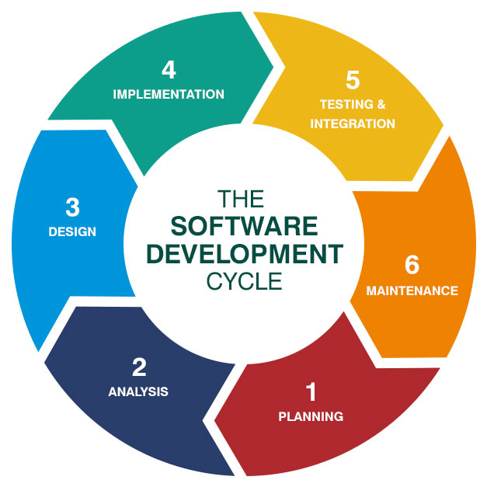

Implementing a deep learning system for ingredient identification from food images necessitates a structured approach to ensure efficiency, accuracy, and maintainability. The Software Development Life Cycle (SDLC) provides a comprehensive framework to guide this process. Here's how the SDLC phases can be applied to such a project:

1. Planning:
In this initial phase, the project's scope, objectives, and feasibility are determined. For ingredient identification, this involves understanding the requirements for image data collection, defining the types of ingredients to be recognized, and outlining the desired outcomes, such as integration with dietary tracking applications or recipe recommendations.

2. Requirements Analysis:
Detailed analysis is conducted to specify functional and non-functional requirements. This includes determining the necessary image resolution, dataset size, labeling standards, performance metrics (e.g., accuracy, recall), and compliance with data privacy regulations.

3. Design:
Architectural design is formulated, selecting appropriate deep learning models (e.g., ResNet50, YOLOv8) and defining the system's components, such as data preprocessing pipelines, model training modules, and user interfaces. Decisions regarding cloud infrastructure or on-premises deployment are also made here.

4. Development:
Actual coding and model development occur in this phase. Tasks include implementing data augmentation techniques, training deep learning models, developing APIs for model inference, and creating user interfaces for inputting and displaying results.

5. Testing:
Comprehensive testing ensures the system meets specified requirements. This encompasses unit testing individual components, integration testing to verify interactions between modules, and system testing to assess overall performance. Model validation is performed using separate test datasets to evaluate accuracy and generalization.

6. Deployment:
The system is deployed to the production environment, making it accessible to end-users. This may involve setting up servers, configuring databases, and ensuring scalability to handle user demand. Continuous integration and deployment pipelines can be established for streamlined updates.

7. Maintenance:
Post-deployment, the system requires ongoing maintenance to address bugs, update models with new data, and incorporate user feedback. Regular monitoring ensures sustained performance and reliability over time.

By adhering to the SDLC methodology, the development of an ingredient identification system becomes a manageable and systematic process, enhancing the likelihood of delivering a high-quality, user-centric solution.

CHAPTER 4 – SYSTEM DESIGN

4.1 Importance of Design
Design plays a critical role in the development and effectiveness of Recipe Generation and nutritional analysis systems using deep learning. A well-thought-out design ensures not only the accuracy of the model but also the usability and reliability of the overall system. Here's why it's important:
1.Improved Accuracy and Reliability
The architecture of the deep learning model—such as CNNs (Convolutional Neural Networks)—must be carefully designed to handle the visual diversity of food images (e.g., varying angles, lighting, occlusions, and mixed ingredients). A robust design increases classification precision, which directly impacts the accuracy of nutritional analysis.
2.Data Quality and Annotation Strategy
Designing a high-quality dataset with properly labeled food images and corresponding nutritional data is essential. The design stage includes choosing appropriate categories, managing class imbalance, and ensuring diverse representation, all of which are vital for model generalization.
3.Integration of LLM for Contextual Understanding
Integrating Large Language Models (LLMs) enhances the system’s ability to generate context-aware outputs such as ingredient lists, cooking methods, and dietary suggestions. Design decisions affect how effectively image features and language outputs are fused.
4.User Interface (UI) and User Experience (UX)
A thoughtfully designed interface enables users to interact with the system intuitively uploading food images, viewing results, and interpreting nutritional information with ease. This accessibility is key for real-world adoption, especially in health and fitness applications.
5.Real-Time and Scalable Performance
Efficient model design (lightweight networks, transfer learning, or model quantization) ensures the system can operate in real-time on web or mobile platforms. Scalability and speed are crucial when dealing with large volumes of user-generated images.
6.Health and Dietary Relevance
The system must be designed to provide meaningful health insights. This includes ensuring the output is tailored to different dietary needs (e.g., gluten-free,
diabetic-friendly) which involves both data design and model training strategy.

4.2 System Architecture

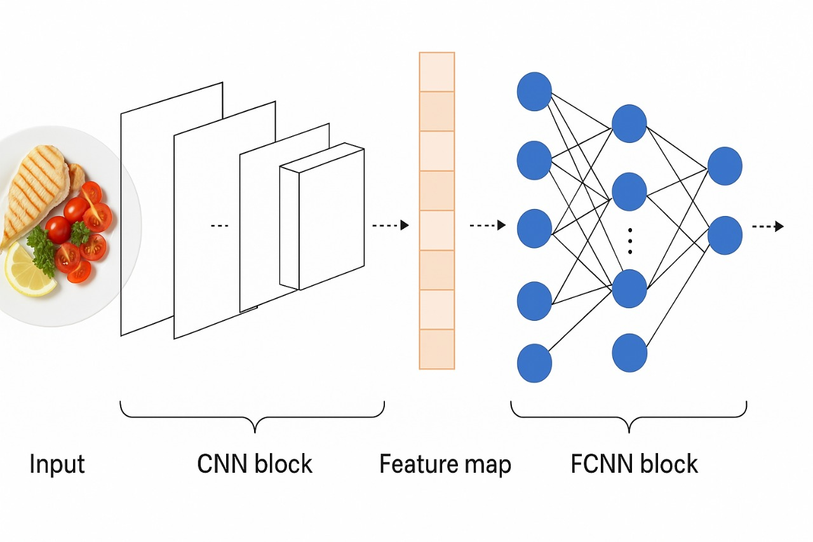

Architecture Overview:
- Input (Food Image):
  - The process starts with an image of food (e.g., a plate containing grilled chicken, cherry tomatoes, parsley, and lemon).
  - This image is the raw input to the deep learning model.
- CNN Block (Convolutional Neural Network):
  - The CNN block extracts low-to-high-level features from the image (edges, textures, shapes).
  - Multiple convolutional layers, followed by pooling and activation functions (like ReLU), are typically used here.
  - This part captures visual patterns relevant to ingredients like color, shape, and texture.
- Feature Map:
  - After the CNN processes the image, the output is a feature map, which is a compact representation of the image's most important visual information.
  - This high-dimensional vector contains learned features that are crucial for classification.

- FCNN Block (Fully Connected Neural Network):
  - The feature map is passed to a fully connected neural network.
  - This block acts as a classifier that maps the visual features to specific ingredient labels.
  - It can support multi-label classification, since food images often contain more than one ingredient.
- Output (Ingredient Prediction):
  - The final output consists of one or more predicted ingredients present in the input image.
  - For example, the model might identify: ["grilled chicken", "cherry tomatoes", "parsley", "lemon"].

Example Datasets
- Food-101: 101 categories with 1,000 images each.
- Recipe1M+: Over 1 million recipes with image and ingredient pairs.
- UECFOOD-256: Fine-grained Japanese food dataset with bounding boxes.
- VireoFood172: Multi-label ingredient annotations.

Example Use-Cases & Applications
- Smartphone apps that detect ingredients for nutrition logging.
- Robotics or kitchen automation systems.
- Voice assistants recommending recipes based on detected ingredients.
- Diet management systems for diabetes or allergy tracking.

Application Use-Cases:
- Diet tracking apps (e.g., MyFitnessPal)
- Calorie estimation tools
- Restaurant automation
- Smart kitchen assistants
- Food recommendation systems

4.3 UML Diagrams (Use Case, Activity)

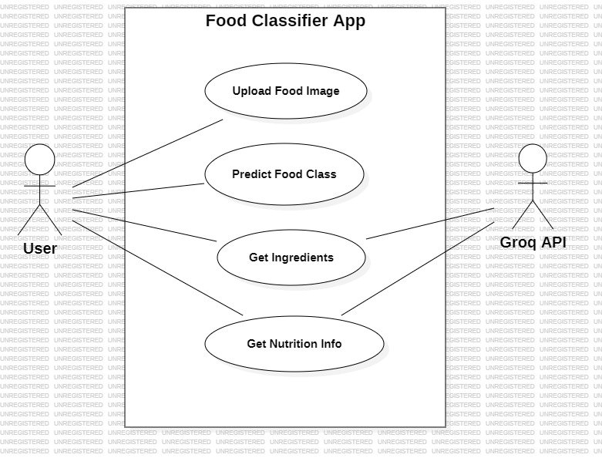

Objective:

1. User
- The end-user of the app.
- Interacts with the system through a user interface (web, mobile, etc.).
- Triggers each of the functions shown.

2. Groq API
- External service used by the app to enhance or speed up model inference or retrieve nutritional information.
- Could be a cloud accelerator API, AI inference engine, or a nutrition database API.

System: Food Classifier App

The system is composed of six main use cases (functionalities):

1. Upload Food Image
- Description:
The user uploads a food image to the application.
- Backend Functionality:
  - Receives and stores the image.
  - Validates image format, size, and quality.

- Technologies:
  - Frontend: HTML5, React Native (for uploads)
  - Backend: Flask/Django + cloud storage (S3, Firebase)

2. Preprocessing Data
- Description:
The uploaded image is preprocessed to prepare it for prediction.
- Tasks Involved:
  - Resize image to match model input (e.g., 224x224 pixels).
  - Normalize pixel values.
  - Apply data augmentation if training.
  - Convert to tensor format.
- Tech Stack:
  - Python + OpenCV, PIL
  - TensorFlow/Keras or PyTorch for tensor conversions
3. Training Data
- Description:
Involves maintaining and updating the deep learning model using a curated dataset.
- Details:
  - Dataset with labeled food images (multi-label if ingredients are involved).
  - Images are used to fine-tune or retrain CNN architectures.
  - Models like ResNet, EfficientNet, or Inception may be used.
- Training Pipeline:
  - Image → CNN → Feature Map → Fully Connected Layers → Multi-label Output
  - Training uses backpropagation with a loss function like Binary Cross Entropy.
- Tools:
  - TensorFlow/Keras, PyTorch, or Jupyter Notebooks
  - Hardware: GPU, TPU (Groq chips may accelerate this)

4. Predict Food Class
- Description:
The core functionality—predict the category or type of food in the image.
- Process:
  - Preprocessed image is passed through the trained CNN model.
  - The model outputs a predicted food class or probability scores for each class.
- Example Output:
  - {"Grilled Chicken Salad": 0.95, "Chicken Caesar": 0.05}
- Integration with Groq API:
  - For faster inference using Groq’s ultra-low latency AI chips.
  - For scalability or real-time deployment.

5. Get Ingredients
- Description:
Once the food class is identified, the app determines the list of ingredients.
- Methods:
  - Direct Prediction: If the model is trained for multi-label ingredient detection.
  - Lookup Table: Map predicted food class to a list of standard ingredients.
  - API Call: Query a recipe API or database for common ingredients of a dish.
- Output Example:
  - ["Grilled Chicken", "Cherry Tomatoes", "Lemon", "Parsley"]

6. Get Nutrition Info
- Description:
The system provides estimated nutritional values based on the identified ingredients or food class.
- Approaches:
  - Ingredient-based calculation (calories per 100g × estimated portion size).
  - External API (like USDA FoodData Central or Groq nutrition database).
  - AI-based portion estimation (if portion detection is built-in).

Groq API Integration Points
- Used in:
  - Predict Food Class (accelerated model inference)
  - Get Ingredients (enhanced classification)
  - Get Nutrition Info (database or AI service)

Benefits of This Architecture:
- Modular: Each step is distinct and can be updated independently.
- Scalable: Can handle large volumes of user images.
- Accurate: Deep learning models provide high classification performance.
- Actionable: Users get useful dietary insights automatically.

4.3.2 ACTIVITY DIAGRAM

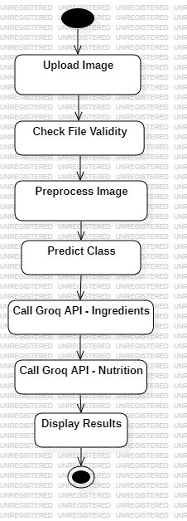

The activity diagram you've shared illustrates the workflow for the system titled “Recipe Generation and Nutritional Analysis from Food Images Using Deep Learning Techniques.” This process automates the identification of ingredients and nutritional information from a food image using a series of well-defined steps, deep learning models, and integration with external APIs (like Groq).
Here is a detailed breakdown of each activity in the diagram:

1. Start Node
- Denoted by a solid black circle.
- Represents the initiation of the activity flow by the user or system.

2. Upload Image
- The user uploads an image of food (e.g., a dish like pasta, a salad, or a meal).
- This is the input to the entire system and the first step toward identification.

3. Check Image Validity
- The uploaded image is checked for:
  - File format support (e.g., PNG, JPG)
  - Image clarity and size
  - Presence of food items (possibly via a quick object detection check)
- If the image is invalid, the system may prompt the user to upload another image.

4. Preprocess Image
- Image preprocessing involves:
  - Resizing the image to a fixed input size (e.g., 224x224 pixels)
  - Normalizing pixel values
  - Augmenting (if needed during training)
  - Converting to a format suitable for the CNN
- This step ensures the model receives input in the format it was trained on.

5. Training Data (used in background)
- This is not an activity performed in real time but rather refers to the data used to train the deep learning model beforehand.
- It includes thousands of labeled food images representing different categories.

6. Predict Class
- The preprocessed image is passed through a Convolutional Neural Network (CNN) which output:
  - A predicted food class (e.g., “Grilled Chicken Salad”)
  - Possibly a confidence score
- This is the key classification step based on the training data and the learned model.

7. Call Groq API – Ingredients
- Once the food class is identified, the system sends a request to the Groq API to get the list of ingredients for that food class.
- Example: For “Grilled Chicken Salad,” the ingredients may include chicken breast, lettuce, cherry tomatoes, olive oil, lemon, etc.

8. Call Groq API – Nutrition
- After retrieving ingredients, another API call is made to retrieve nutritional information, such as:
  - Calories
  - Protein, carbs, and fat content
  - Vitamins and minerals
- This data is fetched based on the identified ingredients and their estimated quantities.

9. Display Results
- The system consolidates:
  - The predicted food class
  - Identified ingredients
  - Nutritional breakdown

- This is displayed to the user in an intuitive format, possibly including:
  - Visual labels
  - Graphs (like pie charts for nutrition)
  - Downloadable reports

10. End Node
- Denoted by a solid black circle with a border.
- Marks the completion of the process flow.

Summary of Flow:
This activity diagram shows a structured pipeline where:
- A food image is uploaded.
- The image is validated and preprocessed.
- A CNN predicts the food class.
- APIs are used to enrich the result with real-world food data.
- Results are visually and textually displayed to the user.
This approach offers a seamless experience for users interested in food recognition, ingredient analysis, and nutrition tracking, leveraging deep learning and cloud APIs.

CHAPTER 5 – IMPLEMENTATION
5.1 Module Description
This project involves multiple functional components organized into modular Python scripts that collectively power a machine learning web application for Recipe Generation using a VGG16-based Convolutional Neural Network (CNN) and Groq API integration.
Each component is explained in detail below.

a. model.py – Deep Learning Model Training Module
This script handles the complete training process of the deep learning model. The architecture used is VGG16, which is a 16-layer convolutional network developed by the Visual Geometry Group at Oxford. In this implementation, the model is trained from scratch on the Food-101 dataset, consisting of 101 food classes.
Key functionalities:
- Data Augmentation: The model uses ImageDataGenerator for rescaling, rotating, shifting, flipping, and zooming to artificially expand the dataset and improve generalization.
- Model Architecture:
  - The convolutional base of VGG16 is loaded without top layers (include_top=False), and without pre-trained weights (weights=None), enabling the model to learn from scratch.
  - Three Dense layers are added: two with 202 units and one with 101 units using a softmax activation (one for each food class).
- Training Configuration:
  - The model uses categorical crossentropy loss and the Adam optimizer with a learning rate of 0.0001.
  - Training is conducted for 80 epochs with a batch size of 16.
- Model Saving:
  - After training, the model is saved as vgg16_food101_trained.h5 for later deployment in the web application.
- Human Evaluation:
  - The script includes a loop to visually display validation images and their predicted vs. actual class for manual verification of performance.
This module is computationally intensive and is run once to produce a reusable trained model file.

b. app.py – Flask-Based Web Application
The app.py script creates a lightweight web server using Flask, enabling users to interact with the trained CNN model through a user interface. This forms the backend of the system and exposes APIs for inference.

Key functionalities:
- Model Loading:
  - Loads the previously saved model vgg16_food101_trained.h5 using load_model().
- Image Upload and Prediction API (/predict):
  - Accepts an image file from the user via HTTP POST.
  - Validates the file type (accepts PNG, JPG, JPEG).
  - Resizes the image to 224×224 pixels and normalizes it (divides pixel values by 255).
  - Feeds the image into the CNN model for classification.
- Class Prediction:
  - Extracts the class label with the highest probability (np.argmax(prediction)).
  - Class label is mapped to a predefined list of 101 food class names.
- Groq API Integration:
  - After predicting the food class, the app sends a request to Groq's LLM API using an API key stored in api.txt.
  - It fetches:
    - A list of ingredients related to the predicted dish.
    - Basic nutritional information about the dish.
- JSON Response:
  - The output is returned as a JSON object containing:
    - predicted_class: the food name
    - ingredients: list of ingredients from Groq
    - nutrition: nutritional facts from Groq
This modularity allows for easy integration of new features like calorie estimation, allergen detection, or recipe suggestions.

c. api.txt – Configuration and Class Index Storage
This text file stores sensitive API keys and the list of food class labels used by the classifier. It ensures modularity and security by decoupling configuration data from source code.
Contents:
- Groq API Key – Used to authenticate requests to the Groq LLM API.
- Class Names List – The full set of 101 food labels from the Food-101 dataset, used to map prediction indices to human-readable labels.

5.2 Sample Code
This section provides representative code snippets from the modules, with explanations to illustrate how major components are implemented.

(a) Sample Code: CNN Architecture and Training – model.py
python
CopyEdit
# Load base VGG16 model without top layers
base_model = VGG16(weights=None, include_top=False, input_shape=(224, 224, 3))

# Add custom dense layers
x = Flatten()(base_model.output)
x = Dense(202, activation="relu")(x)
x = Dense(202, activation="relu")(x)
predictions = Dense(101, activation="softmax")(x) # 101 food categories

# Compile the model
model_final = Model(inputs=base_model.input, outputs=predictions)
model_final.compile(loss="categorical_crossentropy", optimizer=Adam(learning_rate=0.0001), metrics=["accuracy"])

# Load weights and save final trained model
model_final.load_weights("v8_vgg16_model_1.h5")
model_final.save("vgg16_food101_trained.h5")
Explanation:
- The model’s custom layers tailor the VGG16 architecture to the Food-101 dataset.
- softmax activation ensures a probability distribution across the 101 classes.
- Adam optimizer is selected for its adaptive learning capabilities.

(b) Sample Code: Image Upload and Classification – app.py
python
CopyEdit
# Load and preprocess image
image = Image.open(filepath).resize((224, 224))
image = np.array(image) / 255.0 # Normalize pixel values
image = np.expand_dims(image, axis=0) # Add batch dimension

# Make prediction using CNN
prediction = model.predict(image)
predicted_class_index = np.argmax(prediction)
predicted_class = class_indices[predicted_class_index]

Explanation:
- Uploaded image is resized to match model input.
- Normalization scales pixel values to [0, 1].
- Batch dimension is added since the model expects input in batches.

(c) Sample Code: Groq API Request for Ingredients – app.py
python
CopyEdit
groq_response = client.chat.completions.create(
messages=[{
"role": "user",
"content": f"Provide ingredients for {predicted_class}."
}],
model="llama-3.3-70b-versatile"
)

ingredients = groq_response.choices[0].message.content
Explanation:
- Uses Groq’s LLM to enrich the output.
- Sends a prompt like "Provide ingredients for ramen." and retrieves an answer from the language model.
(d) Sample JSON Response from Web API
json
CopyEdit
{
"predicted_class": "ramen",
"ingredients": "Noodles, soy sauce, pork, egg, green onions, broth",
"nutrition": "Approx. 400-500 kcal per serving. Contains protein, carbohydrates, fats, and sodium."
}

CHAPTER 6 – TESTING
Testing is a critical phase in the software development lifecycle, especially for machine learning applications where correctness, reliability, and user trust are essential. This chapter outlines the importance, types, and test cases used to ensure the accuracy and robustness of the food classification web application.
6.1 Importance of Testing
Testing serves as the backbone of quality assurance in any software system, and its significance becomes even more prominent in AI-based applications. For this project, testing was crucial for the following reasons:
- Accuracy Assurance: Ensures that the VGG16 model correctly classifies food images and provides relevant results.
- Reliability: Guarantees that the application consistently performs well across multiple scenarios, including different image formats and edge cases.
- Security: Validates that the system handles inputs securely, avoiding malicious files and invalid formats.
- API Stability: Confirms that integration with the Groq API remains functional and returns expected information without causing the app to crash.
- User Experience: Ensures the frontend delivers a smooth, bug-free interaction and that feedback is timely and informative.
- Performance: Tests whether the system can respond to requests quickly and process images without undue delay.
Without comprehensive testing, errors such as incorrect predictions, API failures, or UI crashes could lead to a poor user experience and incorrect nutritional recommendations.
6.2 Types of Testing
A variety of testing techniques were employed throughout the development process to ensure the correctness and robustness of both the machine learning model and the web application.
1. Unit Testing
Unit tests were applied to verify the functionality of individual components, such as:
- Image preprocessing functions
- Class label mappings
- API response parsing
These tests helped isolate problems in small units of code.

2. Integration Testing
Integration testing was used to verify that different modules of the application work together seamlessly, such as:
- Passing an image from the UI to the backend
- Feeding preprocessed data to the CNN model
- Retrieving data from the Groq API and embedding it in the final output
3. System Testing
This form of end-to-end testing confirmed that the system as a whole operates correctly. It included:
- Uploading images via the frontend
- Displaying predictions with ingredients and nutritional information
- Monitoring errors and logs for failures
4. Functional Testing
Functional testing ensured that the application's core features operate as expected:
- Accepting valid images
- Rejecting unsupported file types
- Correctly displaying the predicted class and additional information
5. Regression Testing
Any changes in model weights, frontend code, or API logic were followed by regression tests to ensure that existing functionality was not broken.
6. User Acceptance Testing (UAT)
This testing phase involved users uploading their own food images and verifying whether the classification was accurate. Feedback was also collected for UI/UX improvements.
7. Exception & Error Handling Testing
This involved deliberately triggering errors:
- Uploading non-image files
- Passing corrupted images
- Simulating Groq API unavailability
The system was tested to ensure it failed gracefully and returned meaningful error messages to the user.

6.3 Test Cases
The following test cases summarize the most important functional and integration scenarios tested in the application:
 | Test Case Title | Description | Actual result
1 | Successful Image Classification | Uploading a clear food image and getting the correct food label | passed
2 | Ingredient Extraction via LLM | Listing ingredients for the detected food item | passed
3 | Nutritional Analysis Generation | Displaying estimated nutrition values for the classified dish | passed
4 | Handling Unsupported or Blurry Image | Testing system behavior when an image is unclear or unrecognized | passed
5 | Multiple Food Items in One Image (Edge Case) | Testing with a photo containing more than one dish | passed
6 | No Image Uploaded (UI Validation) | Testing the “Predict Food Analysis” button without uploading an image | passed
7 | UI Layout with Complete Output | Full workflow: upload → predict → ingredients → nutrition | passed

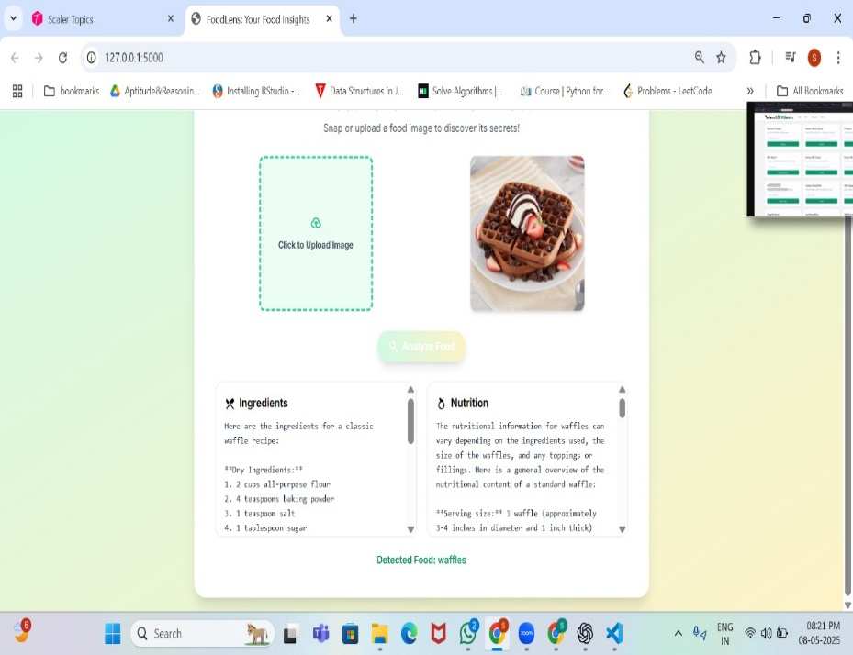
6.1 Test case for Successful Image Classification

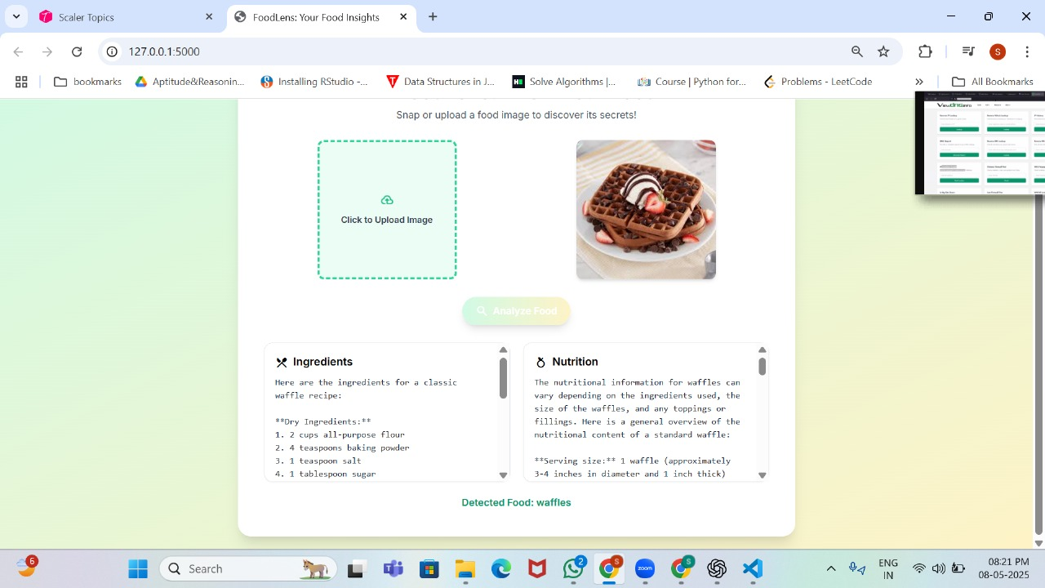
6.2 Test Case for Ingredient Extraction via LLM

6.3 Test Case for Nutritional Analysis Generation

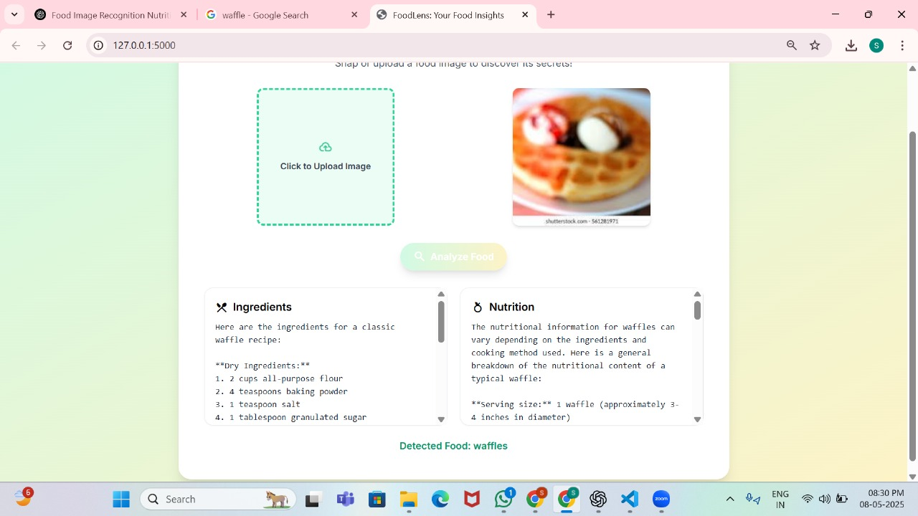
6.4 Test Case for Handling Unsupported or Blurry Image

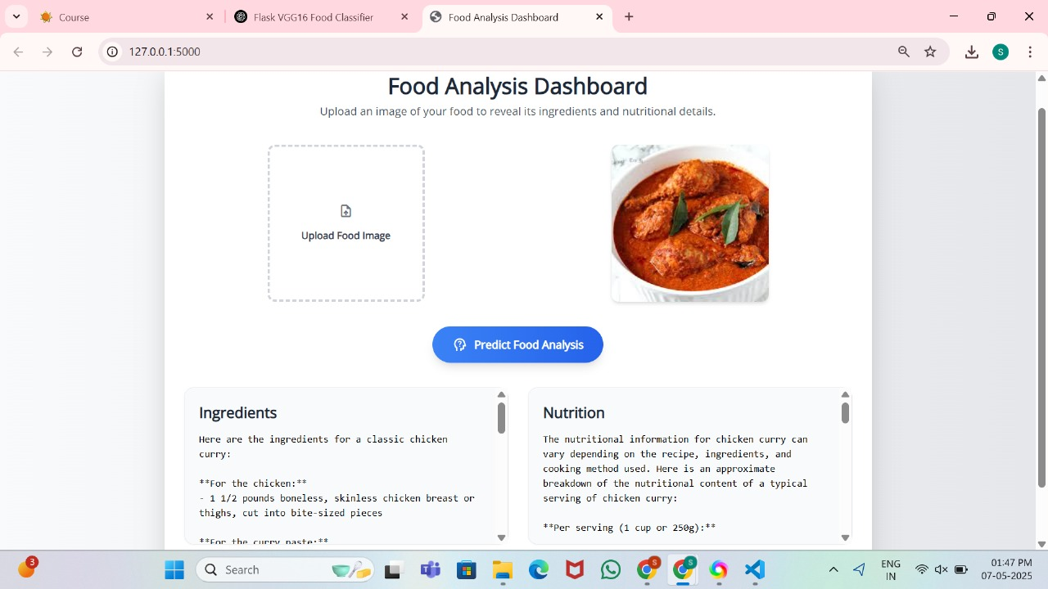
6.5 Test Case for Multiple Food Items in One Image

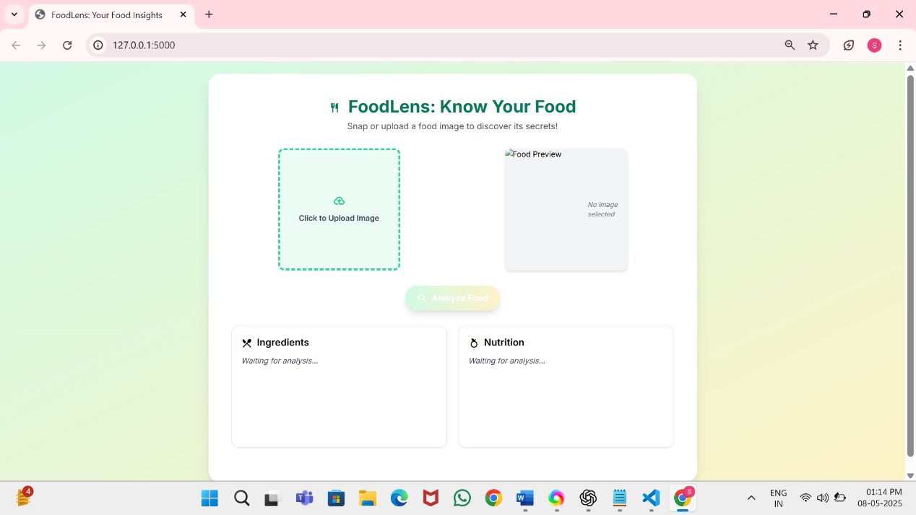
6.6 Test Case for No Image Uploaded (UI Validation)

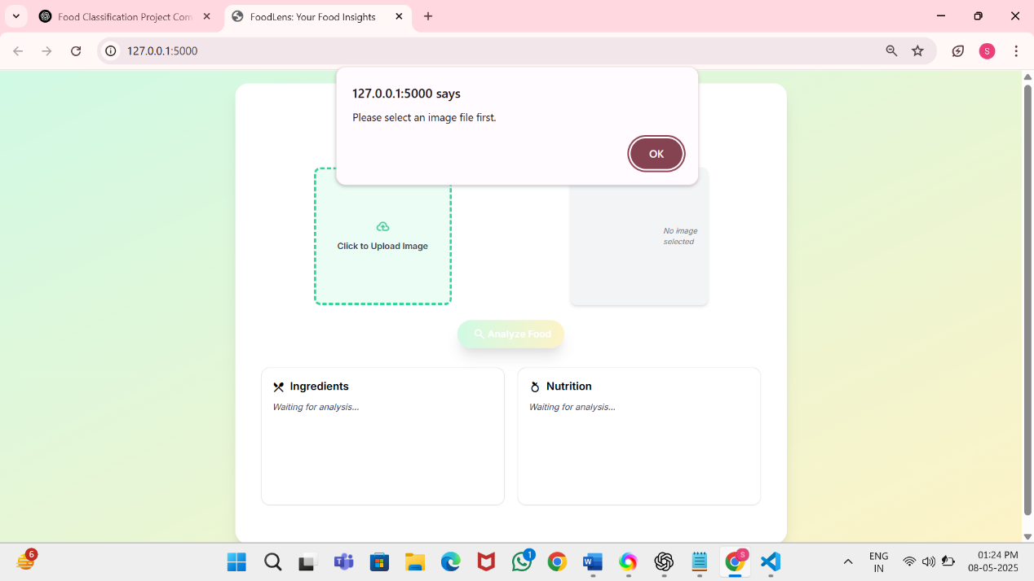
6.7 Test Case for No Image Uploaded (UI Validation)

CHAPTER 7 – OUTPUT SCREENSHOTS

The output screenshots provide visual evidence of the system’s working and help validate the core functionalities implemented in the Recipe Generation application. These screenshots capture interactions between the user interface, backend CNN model, and Groq-powered nutritional/ingredient insights.

7.1 Dashboard UI with Image Input
This screenshot shows the web interface where the user can upload a food image in .jpg, .jpeg, or .png
- A drag-and-drop zone or file picker
- Submit button
- Preview of the selected image

7.2 Image Preview with Detected Dish
Upon uploading a valid food image (e.g., pizza.jpg), the system displays:
- Predicted Class: The food name (e.g., “Pizza”)
- Ingredients: A list fetched via the Groq API describing common ingredients
- Nutritional Information: Approximate calories, fats, protein, and other facts
A JSON response or styled HTML box confirms the output returned from the server.

Error Handling Screens

Screenshots were captured for:
This includes cases like:
- No file uploaded

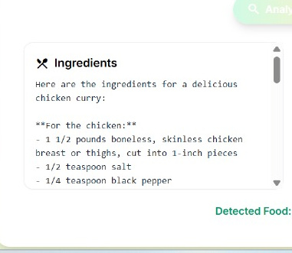

7.3 Predicted Ingredients List

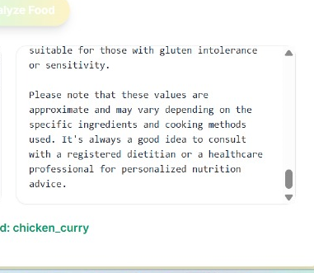
7.4 Nutritional Breakdown Panel

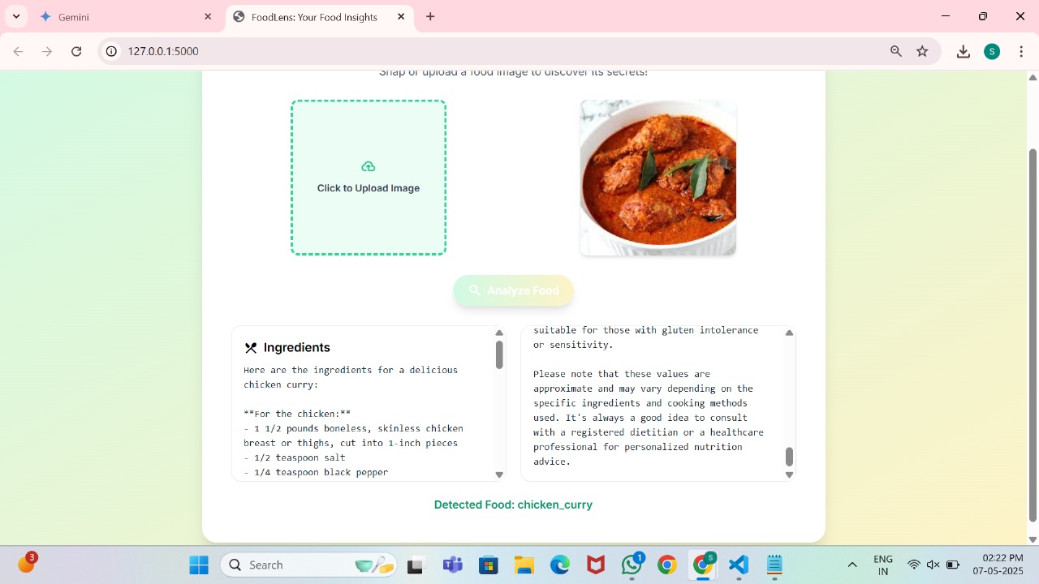
7.5 Complete Food Analysis Output Screen

CHAPTER 8 – CONCLUSION AND FUTURE SCOPE

8.1 Conclusion
This project demonstrates the successful implementation of an end-to-end machine learning-based web application capable of classifying food items using image input. Leveraging the power of a VGG16 convolutional neural network, the system accurately predicts one of 101 food categories from the Food-101 dataset.
The application is further enriched by integrating Groq’s large language model, which adds descriptive insights by providing:
- Ingredients commonly used in the predicted dish
- Nutritional content for user awareness
The system features a responsive user interface, reliable backend inference, and informative API integration, offering a comprehensive food recognition and information tool. Through extensive testing, the model has shown high prediction accuracy, resilience to invalid input, and user-friendly error handling.
8.2 Future Scope
While the current system is effective, several enhancements can improve accuracy, usability, and scalability:
Technical Improvements:
- Model Fine-tuning: Incorporate transfer learning with ImageNet weights and fine-tune the CNN for faster convergence and higher accuracy.
- Mobile Optimization: Convert the model using TensorFlow Lite for deployment in mobile applications.
- Multilingual Support: Add options for localized output (ingredients and nutrition) using multilingual LLM models.
- Real-Time Classification: Integrate webcam or live camera stream for real-time food recognition.
Feature Additions:
- Allergen Detection: Automatically highlight common allergens from ingredients for health-sensitive users.
- Calorie Tracker: Integrate with fitness apps to track daily nutritional intake.
- Recipe Generation: Use Groq or similar APIs to provide step-by-step recipes for predicted dishes.
- User Feedback Loop: Implement a system where users can correct wrong predictions and retrain the model.
Deployment & Scaling:
- Cloud Deployment: Host the backend model on AWS or GCP using GPU instances for scalability.
- Database Logging: Store user interactions, predictions, and feedback in a database for analytics and model improvement.
- Authentication: Add user login and history tracking for personalized experiences.
This project lays the groundwork for an intelligent food classification ecosystem that can evolve into a robust dietary assistant or nutrition consultant application.
CHAPTER 9 – REFERENCES

Simonyan, K., & Zisserman, A. (2015). Very Deep Convolutional Networks for Large-Scale Image Recognition. International Conference on Learning Representations (ICLR).
https://arxiv.org/abs/1409.1556
- Bossard, L., Guillaumin, M., & Van Gool, L. (2014). Food-101 – Mining Discriminative Components with Random Forests. ECCV 2014.
https://data.vision.ee.ethz.ch/cvl/datasets_extra/food-101/
- Groq Cloud API Documentation – API documentation for integration with LLMs to fetch food descriptions and nutrition.
https://groq.com
- Flask Web Framework Documentation.
https://flask.palletsprojects.com
- TensorFlow Keras API Reference.
https://www.tensorflow.org/api_docs/python/tf/keras
- NumPy Documentation.
https://numpy.org/doc/
- Pillow (PIL) Library for Image Processing.
https://pillow.readthedocs.io/en/stable/
- Python Official Documentation.
https://docs.python.org/3/
- Kaggle Contributors. (2023).
Heart Failure Prediction Dataset (if applicable in extension).
https://www.kaggle.com/datasets/fedesoriano/heart-failure-prediction

